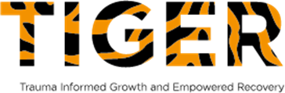
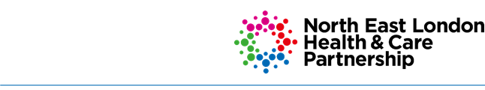

North East London Child Sexual Abuse (NEL CSA) Hub
The NEL CSA Hub provide a holistic, child-centred and integrated approach to supporting the recovery of children and their families when there have been concerns about sexual abuse. We provide a service across 7 North East London boroughs - Barking & Dagenham, City & Hackney, Havering, Newham, Redbridge, Tower Hamlets and Waltham Forest.
The hub is a developing multi-disciplinary team currently comprising of specialist paediatricians who are trained on recognising indicators of abuse; a health play specialist who provides support to children throughout the CSA medical assessment and a social care liaison officer (SCLO) who provides communication and partnership working across the 7 boroughs and expert advice to clinicians and social workers.
The hub includes Barnardo’s TIGER Light who can provide emotional wellbeing support to children and their parents/carers in their recovery post sexual abuse.

Child Sexual Abuse (CSA) medicals at the NEL CSA Hub
The NEL CSA hub provide specialist CSA medical assessments when the abuse occurred over 7 days ago and when there is no requirement for forensic examination for evidential purposes. If the abuse occurred within 7 days or if there is need for an urgent medical assessment, social workers are advised to consult with the Havens in the first instance.
The CSA medicals are held at a specialist CSA clinic at the Royal London Hospital and can provide a holistic health assessment, head to toe examination including genital examination, STI screening, pregnancy screening and follow up appointments.
We recognise the impact of traumatic experiences on health and wellbeing and provide a safe space for children to talk about any concerns they have about their body, their health and how they have been coping. The medical assessment is child-centred and set at a pace to keep the child at ease. The child remains in control throughout and is encouraged to have their voice heard about what they feel comfortable happening during the medical assessment.
CSA medical referrals are made by social workers, who must be present during the appointment. The social worker will provide background information to the clinicians and provide support to the child and parents/carers throughout the appointment.
Following the medical appointment, the paediatrician will produce a report with the findings from the medical examination and any recommendations. A copy of the report will be sent out to social workers, GP and parents/carers if appropriate, usually within 5 days of the appointment.

Emotional wellbeing support across NEL
Barnardo’s provide bespoke emotional wellbeing intervention to children and their families to support their recovery post sexual abuse through their TIGER Light service. TIGER stands for Trauma Informed Growth and Empowered Recovery. They can provide direct work sessions with the child (generally up to 10 although this can be extended to 16 if the needs of the child require an extension). Children are seen at a safe venue of their choice; this is often their school or another venue in their home borough. They can also provide sessions with the parent/carer (usually 1-2 sessions although with younger children or children with special needs it may be more appropriate to provide more sessions with the parent and less with the child-this is decided on a case-by-case basis.) They collaborate with professionals in the child’s network and will support onward referrals if needed.

Referrals pathways for CSA services across NEL
The Havens - Emergency CSA medical assessments (within 7 days of abuse occurring or if the need is urgent) Social workers must contact The Havens on 020 3299 6900 (https://www.thehavens.org.uk/) They are open 24 hours, 7 days a week. The Havens offer emergency appointments when there is a need for acute medical and forensic assessments for evidential purposes.
NEL CSA Clinic – non-urgent CSA medical assessments - Social workers must make a referral to the NEL CSA clinic via the attached referral form and emailed to bartshealth.nelcsahub@nhs.net
Prior to offering an appointment at the NEL CSA clinic, each referral is discussed during the weekly intake meeting to ensure the suitability and timing of the medical assessment. Any further requests for information or recommendations are made to the referrer by the SCLO.
For any queries about CSA concerns and whether a referral is appropriate, social workers can contact the NEL CSA Hub SCLO: Naz Taner; n.taner@nhs.net (please note that if there are any concerns about a child’s immediate safety, social workers should raise this with their manager first).
Barnardo’s TIGER Light service – Social workers need to make a separate referral to Barnardo’s for emotional wellbeing support via the following online portal:
Make a referral to a TIGER service | Barnardo's (barnardos.org.uk)
It is advised that referrals to Barnardo’s are usually made in conjunction with a referral for a CSA medical assessment to ensure that children and their parents/carers have access to all support available to them.

