Learning Disability and Autism
There are 1.5 million people with a learning disability in the UK with 351,000 being children aged 0 to 17.
A learning disability occurs when the brain is still developing (before, during or soon after birth). It is a lifelong condition that starts before adulthood and affects somebody across all areas of their life. It characterised by a:
- significantly reduced ability to understand new or complex information and to learn new skills
- reduced ability to cope independently
There are different types of learning disability, which can be mild, moderate or severe and can have a profound lasting effect on development. The level of support someone needs depends on the individual.
Someone with a mild learning disability may only need support with things like getting a job. However, someone with a severe or profound learning disability may need full-time care and support with every aspect of their life. They may also have a physical impairment.
Specific learning difficulties, which only affect a subset of skills, such as dyslexia, are not the same as a learning disability. It is important to note that everybody with a learning disability is different and has their own unique strengths, difficulties and experiences. It is important to see the person first, regardless of their diagnosis. People do not fit into "boxes".
While some people have said that labels and diagnoses were helpful to gain access to services and get help, others did not feel the same way. "Labels” follow people for life and change how they feel about themselves. Assessments should be used to help people to be supported rather than list the things that the person cannot do.
Autism
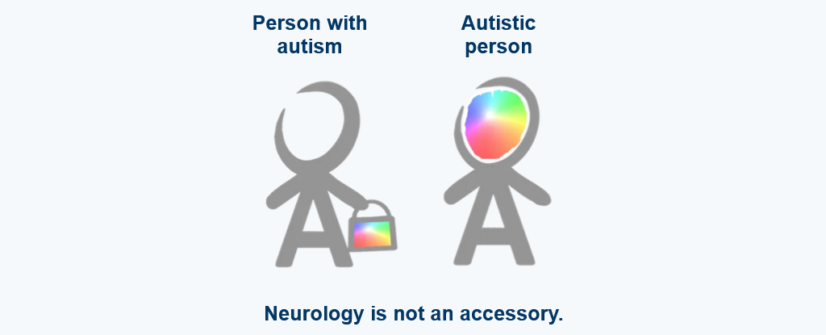
Autism is not a learning disability but it can affect learning and dealing with daily life. 1 in 100 people are autistic and there are around 700,000 autistic adults and children in the UK. It is a lifelong disability which affects how people communicate and interact with the world.

Three times as many males as females are diagnosed with autism. There are multiple theories about this, including a range of biological and environmental factors which may mean men and boys have a higher prevalence of autism. However, it is also felt that women and girls may be better at masking or camouflaging their difficulties and that autistic traits in girls and women can look quite different. This may mean that autism is under-reported and therefore under-diagnosed in females.
There is some evidence that rates of autism are higher in gender-diverse people, but the reasons why are unknown
Autism can occur across the full range of intellectual ability which means that some people with autism may also have learning disabilities.
Autism is often referred to as spectrum. Every autistic person has a unique combination of traits and sensitivities. Instead of affecting cognitive behaviour across the board, autism specifically affects social and communication skills, thinking flexibly and sensory perceptions. It can also occur across the full range of intellectual ability and may impact learning, pace of response and behaviour significantly.
As with learning disabilities, executive functions of planning, adaptable thinking etc. are likely to be reduced. An autistic person may appear to have reduced intellectual abilities but there are many people of average to extremely high intellectual capacity. An autistic person with high intellectual functioning may run their own company, but struggle to do their washing independently or remember to shower regularly. Likewise, an autistic person with a learning disability may receive 24/7 support due their needs, but they could have a particular interest in washing machines and be able to do laundry independently and know lots about different types of machines
Autistic people are sometimes described as having a "spiky profile" of skills, meaning that they can be very skilled in one area and need a lot of support in another. Each day could be different and the level of support someone needs may change as a result. Because of the "spiky profile" we should not underestimate people's skills and abilities, or conversely, expect them to perform well in all areas. It is important to ask the person how they would like to be supported each time.
Some autistic people may require 24 hour care and support in many areas of their daily lives whilst others have no formal support needs. Others will fall somewhere in between. This does not mean that they are any less autistic.
People may experience varying challenges across different aspects of their lives, and therefore need different types or amounts of support in different areas. As mentioned previously, many call this the "spiky profile" of autism.
We cannot assume that someone's intellectual ability or use of language reflects their needs. Like everyone else, every autistic person is a unique individual with their own strengths and areas of difficulty.
Social Communication and Interaction
Social communication can be challenging for people because of:
- taking things literally and not understanding abstract concepts
- needing extra time to process information or answer questions
- repeating what others say to them (this is called echolalia)
During social interaction people may:
- appear to be insensitive
- seek out time alone when overloaded by other people
- not seek comfort from other people
- appear to behave "strangely" or in a way thought to be socially inappropriate
- find it hard to form friendships
The Learning Disabilities Mortality Review Programme (LeDeR)
People with learning disabilities and autistic people with or without learning disabilities face many health inequalities. The Learning Disabilities Mortality Review Programme (LeDeR) was established in 2015 to review the deaths of people with a learning disability with an aim to learn from those deaths and put learning into practice.
The LeDeR project established that people with learning disabilities are twice as likely to die from avoidable causes related to:
- Delays in diagnosis
- Poor care co-ordination between agencies
- Omissions in care and the provision of sub-standard care
- Poor application of the Mental Capacity Act
- A lack of timely referral to specialists, including learning disability services and neurologists.
In 2021 NHS England and NHS Improvement published “Learning from lives and deaths” - People with a Learning Disability and Autistic People.
This is the new LeDeR policy and the name has changed to reflect the inclusion of autism. From now on, all deaths of autistic people will also be reviewed.
The reviews confirm that people with learning disabilities die younger than those without. Six out of ten people with a learning disability die before they reach the age of 65 compared to one in ten in the general population without.
Men with a learning disability die on average 22 years younger than men in the general population and women die with a learning disability die 26 years younger.
The findings from the Independent LeDeR process following Oliver McGowan’s death have also informed many of the recommendations in this new policy.
GP Registration and Health Plans
All GP’s hold a register of their patients who have a learning disability. Everyone over the age of 14 should be invited for an annual health check and receive a health action plan every year. It is therefore very important to encourage people to sign up to the learning disability register. This will ensure that they are offered flu vaccinations, as well as good health screening for checks such as breast or prostate cancer.
Around 30% of autistic adults have a comorbid learning disability, physical, and mental health conditions. While those with a comorbid learning disability are more susceptible to physical health issues, those without a learning disability are at higher risk of mental health problems.
Autistic adults without a learning disability die 12 years earlier when compared to the general population so it is important that those working in health and social care are aware of these hidden vulnerabilities.
Medication
For a long time people with learning disabilities and autistic people with or without learning disabilities have been given too much or inappropriate medication and their medicine has not been reviewed as often as it could have been. Stopping Over-Medication of People with learning disabilities, autism or both (known as STOMP) and Supporting Appropriate Medication in Paediatrics (known as STAMP) continue to be key priorities.
Please take a look at the Oliver McGowan learning video below
https://youtu.be/ouhKSOGm49g
Constipation
Constipation can be a life-threatening issue for people with a learning disability who are at heightened risk of complications if it is left untreated. 23 per cent of people with a learning disability who died in 2019 had constipation as a long-term condition. The NHS has produced a range of resources for people with a learning disability to highlight the seriousness of the condition https://www.england.nhs.uk/learning-disabilities/improving-health/learning-from-lives-and-deaths/constipation-resources/
https://www.youtube.com/watch?v=R16WY6MLBBU
London Ambulance Support
The London Ambulance Service have coproduced 3 new resources to support people with a learning disability or autistic people when using the ambulance service. This can be required by anyone when least expected however causing significant anxiety and distress.
These resources are designed to help to know what to expect when an ambulance comes to see you including assessments we may ask to complete, the inside of an ambulance and demystifying common concerns.
Using content requested by people with lived experience, we have made an easy read document, social story and a video.

These can be used proactively and in the event of needing an ambulance by people with a learning disability, autistic people and those that support them. By increasing understanding, reducing anxiety and supporting engagement with the service, the resources hope to reduce barriers to accessing the service and promote people getting the help they need with their health in a timely way.

Easy read: https://www.londonambulance.nhs.uk/wp-content/uploads/2023/03/Easy-read-document-When-an-ambulance-comes-to-help-you.pdf

Social story: https://online.fliphtml5.com/jbhej/fihy/#p=1

Video without subtitles : https://www.youtube.com/watch?v=PiIIFlBWZ3k

Video with subtitles: https://www.youtube.com/watch?v=rMfU4XUZxB0

All Age autism strategy here xx

Barking, Havering and Redbridge University Trust (BHRUT) Passports
BHRUT can support patients with Learning Disabilities and/or Autism and their care networks, before, during and after their hospital visit or appointment.
To help this process run smoothly, please visit https://www.bhrhospitals.nhs.uk/help-for-people-with-learning-disabilities/ to download a passport which when completed will provide information about the patient and their healthcare and treatment.
There are a choice of three different passports: children with a learning disability; adults with a learning disability; and autistic people.
The passport should be taken with patients to each hospital visit or stay. This will ensure that the Learning Disability and Autism Team at Queens Hospital in Romford and King Georges Hospital in Goodmayes are aware of any additional needs so that equitable care can be provided and reasonable adjustments made.
Should the patient require additional support during the hospital visit, the Learning Disability and Autism Team should be contacted on 0208 970 5710 or email Bhrut.learningdisabilitiesteam@nhs.net
Arrangements can then be made for a member of the team to support the patient on arrival.
The team work from 9am-5pm Monday to Friday.

