 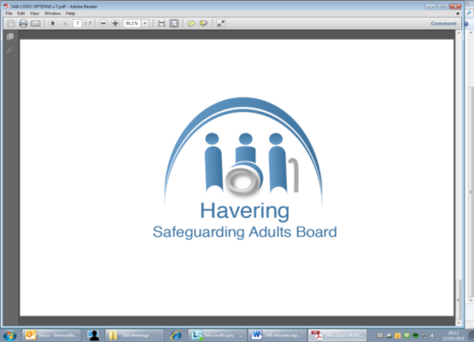

**Financial Support for adults and children in Havering**

With the cost of living rising and many finding themselves in fuel poverty, whether they work or not, Havering Safeguarding Partnership has developed details of local resources who can help with finances, debt, unemployment, food, and homelessness.

**Havering Citizen's Advice** offer information in English and other languages on:

* [help for one-off expenses – the Social Fund](https://www.citizensadvice.org.uk/benefits/help-if-on-a-low-income/help-for-people-on-a-low-income-the-social-fund-and-other-welfare-schemes/#h-help-for-one-off-expenses-the-social-fund)
* [help with the costs of a new baby - maternity grants](https://www.citizensadvice.org.uk/benefits/help-if-on-a-low-income/help-for-people-on-a-low-income-the-social-fund-and-other-welfare-schemes/#h-help-with-the-costs-of-a-new-baby---maternity-grants)
* [funeral payments](https://www.citizensadvice.org.uk/benefits/help-if-on-a-low-income/help-for-people-on-a-low-income-the-social-fund-and-other-welfare-schemes/#h-funeral-payments)
* [cold weather payments](https://www.citizensadvice.org.uk/benefits/help-if-on-a-low-income/help-for-people-on-a-low-income-the-social-fund-and-other-welfare-schemes/#h-cold-weather-payments)
* [community care grants and welfare schemes](https://www.citizensadvice.org.uk/benefits/help-if-on-a-low-income/help-for-people-on-a-low-income-the-social-fund-and-other-welfare-schemes/#h-community-care-grants-and-welfare-schemes)
* [budgeting loans](https://www.citizensadvice.org.uk/benefits/help-if-on-a-low-income/help-for-people-on-a-low-income-the-social-fund-and-other-welfare-schemes/#h-budgeting-loans)
* [crisis loans and welfare schemes](https://www.citizensadvice.org.uk/benefits/help-if-on-a-low-income/help-for-people-on-a-low-income-the-social-fund-and-other-welfare-schemes/#h-crisis-loans-and-welfare-schemes)
* [advance payment of benefit](https://www.citizensadvice.org.uk/benefits/help-if-on-a-low-income/help-for-people-on-a-low-income-the-social-fund-and-other-welfare-schemes/#h-advance-payment-of-benefit)
* [discrimination and the Social Fund](https://www.citizensadvice.org.uk/benefits/help-if-on-a-low-income/help-for-people-on-a-low-income-the-social-fund-and-other-welfare-schemes/#h-discrimination-and-the-social-fund)

**Havering Emergency Assistance Scheme**

If you are on a low income or welfare benefits and have an emergency need, you may be eligible for a payment of up to £100. An emergency payment cannot be claimed if you have already received a payment in the previous month.

More details about the Havering Emergency Assistance Scheme Policy can be found [here](https://www.havering.gov.uk/downloads/file/3731/havering_emergency_assistance_scheme_policy_2020_-_2021).

**Havering Council money advice**

<https://www.havering.gov.uk/covid19moneyadvice>

**Liberty Credit Union**

<https://www.lcu.org.uk/>

Savings and loans support

**DABD**

**tel:0330 054 2500**

Help with benefits advice, filling in forms, finding work,

**Havering Foodbanks**

Collier Row <https://collierrowromford.foodbank.org.uk/>

Harold Hill <https://haroldhill.foodbank.org.uk/>

Rainham <https://rainham.foodbank.org.uk/>

**Havering Harold Hill, Upminster, Romford Christians against Poverty**

<https://www.haveringcommunityhub.com/harold-hill/find/lister/christians-against-poverty--help-with-money_3229>

Debt advice, benefits support, job club

**Hope4Havering**

<https://www.thebreweryromford.com/hope4havering/>

Homeless charity

**Havering Islamic Cultural Centre**

<https://haveringislamiccentre.org.uk/>

Soup kitchen, Saturday morning Food Bank (no voucher or referral needed), clothing,

**Jewish Care** (for Jewish people)

<https://www.jewishcare.org/how-we-can-help-you/jewish-helpline>

Helpline with advice around finances, benefits, meals on wheels, carers, disability

**Clean Slate (Harold Hill)**

<https://bit.ly/Clean_Slate>

advice on finances, benefits, finding work

**Peabody Benefits Advice**

Help with debt, blue badges, housing, Foodbank vouchers

01708 776770 Thursdays at the Havering Community Hub

<https://www.eventbrite.co.uk/e/peabodys-benefit-and-advice-session-tickets-161884178937?utm_campaign=post_publish&utm_medium=email&utm_source=eventbrite&utm_content=shortLinkNewEmail>

**Community Food Shop Harold Hill**

<https://www.yourlocalpantry.co.uk/pantry-listings/london-harold-hill-community-food-shop/>