Havering Dementia Action Alliance

Pocket Telephone Directory

Our thanks to

•

Havering Safer Neighbourhood Board

•

London Borough of Havering

•

The Volunteer Centre

for their help in compiling this directory

Please contact Havering Dementia Action Alliance for more copies of the directories or amendments
01708 431249

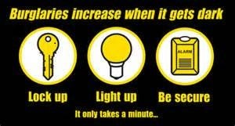

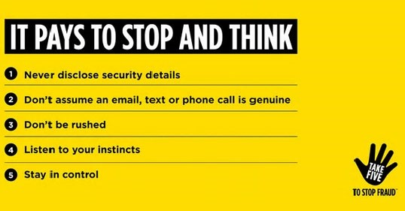

Help and Support | Telephone Number
Age UK for Barking, Dagenham, Redbridge and Havering. | 0208 220 6000
Age UK Care Navigators | 0208 220 6000
Attendance Allowance | 0345 605 6055
Alzheimer’s Society Havering | 01708 739293
Alzheimer’s Society National Helpline | 0300 222 1122
Bus (Freedom) Passes | 0845 275 7054
Christians Against Poverty | 01245 760720
Cinnamon Trust for care of pets for the elderly | 01708 757900
Citizens Advice Havering  www.haveringcab.org.uk | 01708 763531
Community Treatment Team 8.00am to 10.00pm everyday | 0300 300 1660  (treatment)  1661 (therapy)

Help and Support | Telephone Number
Continence Advisory Service | 01708 796500
Crimestoppers | 0800 555 111
Dementia Research Infoline to find out about current research or email  infoline@alzheimersresearchuk.org | 0300 111 5 111
Dementia Support Service | 01708 739293
Dementia UK Advice Line | 0800 888 6678
Dial-a-Ride | 0207 309 8900
Disability & Carers Service | 0345 712 3456
Disability Liaison Nurse Team | 01708 435000 ext 4928
Disabled Go – (Access Able) disabled accessibility guides online www.disabledgo.com | 01438 842710
Disabled Living Foundation  Practical solutions supporting disabled adults, children and older people info@disabledliving.co.uk | 0161 607 8200

Help and Support | Telephone Number
Electricity emergencies (power cut) | 0800 40 40 90
Emergency Dentist  (out of hours and weekends) | 020 8594 0938
Foodbank | 07548 674958
Gas Emergency | 0800 111 999
GP Access Hub  6.30pm to 10.00pm weekdays  8.00am to 8.00pm weekends | NHS 111  020 3770 1888
GP Out of Hours  North Street Medical Practice  Rosewood Medical Centre | 01708 629733  01708 523168
Harold Wood GP Walk In Centre | 01708 792000
Havering Association for People with Disabilities | 01708 476554
Havering Carers Hub  The Hub offers support and information to an adult carer, caring for an individual over 18 years, as well as support groups, awareness training and regular Carer Forums | 01708 961111

Help and Support | Telephone Number
Havering Dementia Action Alliance | 01708 431249
Havering Mind | 01708 457040
Havering Neighbourhood Watch Association. | 01708 747997  07866 335438
Havering Older Adult Mental health Team | 0300 555 1135 ext 66700
Havering Talking Therapies IAPT Service offers counselling to improve mental wellbeing | 0300 555 1042
Havering for the homeless.  Hours of support 7.30pm to 8am | 0789 444 8729  0752 719 2161
Healthwatch Havering  enquiries@healthwatchhavering.co.uk | 01708 303300
Learning Disability Liaison Nurse Team | 01708 435000 ext  4928

Help and Support | Telephone Number
London Fire Brigade for Fire Safety | 0800 028 44 28
Mental Health Direct (24 hours a day) | 0300 555 1000
North East London Clinical Commissioning Group | 020 3688 2300
NELFT NHS Havering Memory Service | 0300 555 1135 ext  66700
Orange Line (hosted and funded by St Francis Hospice) – offers holistic assessments, support and advice 24/7) | 01708 758643
Peabody (Supports anyone over the age of  16 with free advice and resides in Havering)  Here to help  Short term support | 01708 776770  (option 1)  (option 2)
Personal Independence Payment | 0800 917 222
Queens Hospital / King George’s  Hospital for Dementia Nurse and Delirium Nurse Team | 01708 435000 ext 6747 for Queen’s  ext 5719 for KGH
Queens Theatre in Hornchurch | 01708 443333
Reporting crime (emergencies) | 999
Reporting crime (non emergencies) | 101

Help and Support | Telephone Number
Safer Transport Team | 0208 721 2254
Sight Action Havering | 01708 434392
Silver Line | 0800 4 70 80 90
South Hornchurch Walk In Centre | 01708 576000
Stop Hate UK - 24 hour service to report  crimes of race , religion or sexual orientation | 0800 138 1625
Tapestry (Advice & Info on dementia) | 01708 797700
Tax help for older people | 0845 601 3321
The British Red Cross Help Not Hospital Service | 07950915708 /  07908447063
Tuvida (Home care provision that enables periods of respite for carers) | 01708 757242
Victim Supportline | 08 08 16 89 111
Volunteer Bureau | 01708 922214
Water Emergency | 0845 7820999
Water Leak Line | 0800 526337
Help and Support | Telephone Number
Welfare Rights Unit Advice Line | 01708 434444
Young Dementia UK | 01993 776295
Havering Council Useful Numbers | Telephone Number
Anti-Social Behaviour Team - 24 hours service. Messages are recorded | 01708 726060
Environmental Health - call to report noise problems | 01708 432777
Havering Adults Safeguarding Team | 01708 432000
Havering Access Team (HAT)  (office hours 9am - 5pm)  Havering Access Team will be the first point of contact for all enquiries into Adult Social Care. This is a multidisciplinary team of social workers, occupational therapists and initial contact workers. | 01708 432000  Option 4
Havering Council Useful Numbers | Telephone Number
Havering Adult Social Care Crisis  Team (to insert )  (out of office hours 5pm - 9am) | 01708 433999
Havering Benefits Advice Line -  Answer message need claim number | 01708 433996
Havering Equipment repairs  (LBH provided) for assisted home adaptations / mobility  Out of Hours from 5pm - 9am  Mon - Fri and bank holidays | 01708 432000  01708 433999
Streetcare - call to report rubbish  dumping, abandoned vehicles and graffiti | 01708 432563
Telecare  Telecare is a range of equipment to assist people to remain independent | 01708 432843
Telecare Respond Team | 01708 434216

printed and designed by ICT Printing Services 02033731780

